Bank Branch Simulation — Modeling & Simulation Mini-Project
Oct 19, 2026 · @Zeyad Salem

Overview
We model a bank branch as a queueing system and test four staffing options; adding one ATM cuts the average wait from 4.3 to 0.7 minutes, and an ATM with only 2 tellers matches today's 3-teller service. The TA discussion is in the week of 17–22 Oct.
- ☐ Form the team (3–5 people) and add names here
- ☐ Read the AnyLogic research section and be ready to explain it
- ☐ Build the model in AnyLogic (Personal Learning Edition) using the build guide
- ☐ Run the four scenarios and compare against the Python results below
- ☐ Attend the lab and discuss with the TA
Deliverable | Where
AnyLogic research | Section 2
System design | Section 3
AnyLogic model (.alp) | Built by the team from Section 4
Validation model | bank_sim.py (Python/SimPy), results in Section 5

Research: the AnyLogic platform
AnyLogic is a Java-based simulation tool and the only mainstream one that combines all three simulation methods in a single model. Models are built visually from library blocks, and any block can be extended with Java code.

The three modeling methods
Method | Abstraction level | Thinks in terms of | Typical use
Discrete-event (DES) | Medium–low | Entities flowing through a process of queues and resources | Banks, clinics, factories, call centres
Agent-based (ABM) | Any | Individuals with their own state and rules who interact | Customer behaviour, epidemics, markets
System dynamics (SD) | High | Stocks, flows and feedback loops | Population, supply chain policy, economics
Multimethod modeling is AnyLogic's main selling point: for example, customers can be agents with their own patience (ABM) while moving through a teller process (DES). Our bank model uses DES, the right method for a queueing system.

Libraries and features
- Process Modeling Library: the DES blocks we use (Source, Queue, Service, SelectOutput, ResourcePool, Sink)
- Industry libraries: Pedestrian, Road Traffic, Rail, Fluid and Material Handling
- Experiments: single run with animation, parameter variation, Monte Carlo, sensitivity analysis and OptQuest optimization
- Visualization: 2D and 3D animation plus built-in statistics and charts
- AnyLogic Cloud: run and share models in a browser

Editions
There are three editions: Personal Learning Edition (PLE, free), University Researcher, and Professional (AnyLogic Help). PLE is licensed only for classroom instruction and personal learning. Its main limits:
- At most 10 agent types per model and 200 flowchart blocks per agent type
- Model time is capped at 5 hours, except in the Process Modeling Library, so our bank model is not affected
- At most 50,000 dynamically created agents per model
- OptQuest is limited to 500 iterations and 7 decision variables
The current desktop line is AnyLogic 8; AnyLogic 9 is in technology preview (version 0.4, May 2026) (release notes).

Where it is used
Manufacturing and warehouses, supply chains, healthcare (patient flow, bed planning), transport and pedestrian flow (airports, rail stations), and business processes such as banking and call centres.

Compared with alternatives
Tool | Methods | Cost | Strength | Weakness
AnyLogic | DES, ABM, SD | Free PLE; paid editions | Multimethod, strong animation, Java extensibility | Steeper learning curve; Java needed for custom logic
Arena | DES | Free student edition | Long-standing teaching standard | DES only; dated interface
Simio | DES with objects | Free student edition | Object-oriented, good 3D | Less used for ABM/SD
SimPy (Python) | DES | Free, open source | Full code control, easy statistics | No visual builder or animation
Vensim | SD | Free PLE | Simple SD diagrams | SD only
Pros: one tool for every method, animation that makes results easy to present, free edition, large example library. Cons: heavy desktop install, PLE limits for big models, and custom logic needs Java.

The system: a bank branch
Customers arrive at a branch open 6 hours, take a ticket and wait in one queue for the next free teller; anyone who sees 12 or more people waiting leaves. In the ATM scenarios, customers who only need cash use the ATM instead.
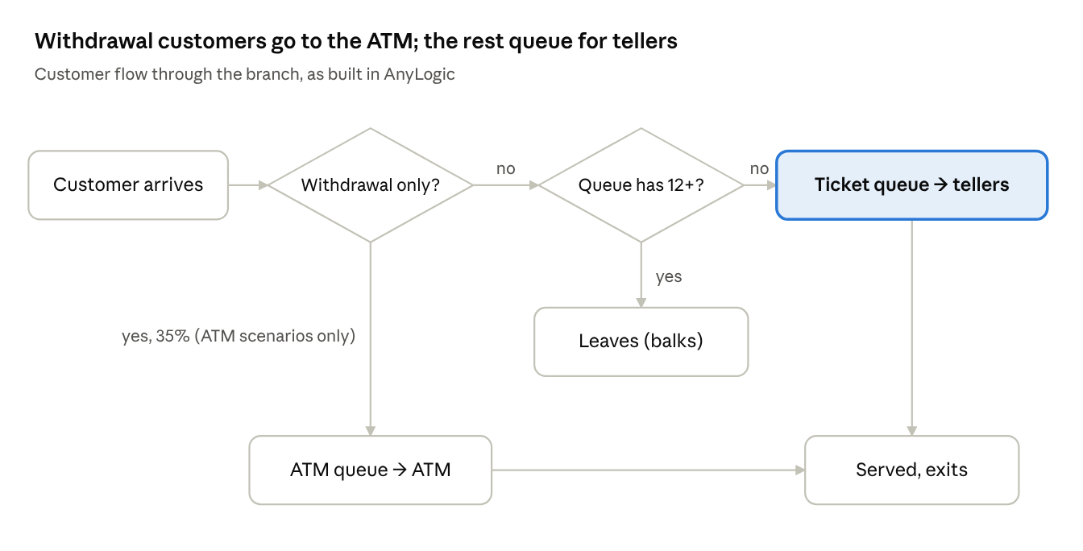
bank branch process flow · 2 decisions, 2 service points

Model elements
Element | Type | Value | Why
Customers | Entity (agent) | Poisson arrivals, 40 per hour (mean 1.5 min apart) | Random independent arrivals are the textbook bank assumption
Tellers | Resource | 3 (baseline) | Typical small branch
Teller service | Delay time | Triangular(2, 3.5, 7) min, mean 4.17 | Most transactions are short, a few are long
ATM | Resource | 1 (scenarios S2, S3)
ATM service | Delay time | Triangular(1, 1.5, 3) min, mean 1.83
Withdrawal share | Probability | 35% | Share of customers who only need cash
Balking | Rule | Leave if 12+ already waiting | People walk out of a crowded branch
Run length | Time | 6 h of arrivals, then serve everyone inside | Terminating simulation, starts empty
Replications | Count | 30 per scenario | Enough for 95% confidence intervals

Assumptions
- One shared ticket queue, first come first served
- Customers do not renege (leave after joining) or switch lines
- Arrival rate is constant through the day (no lunch peak)
- Tellers take no breaks; ATM never runs out of cash
- Parameters are assumed for illustration; observing a real branch for one hour would let you replace them

Performance measures (KPIs)
Average wait, share of customers waiting over 10 minutes, average and maximum queue length, teller and ATM utilization, share of customers lost to balking, and overtime after closing.

Scenarios
Scenario | Tellers | ATM | Question it answers
Baseline | 3 | No | How bad is the current setup?
S1 | 4 | No | Does hiring a teller fix it?
S2 | 3 | Yes | Does an ATM fix it instead?
S3 | 2 | Yes | Can an ATM replace a teller?

AnyLogic build guide
The model needs 8 blocks from the Process Modeling Library and takes about 1–2 hours to build. Block names below match AnyLogic 8's palette; exact menu labels can differ slightly between versions.

1. Set up the model
- Install AnyLogic Personal Learning Edition (free) from anylogic.com.
- File → New → Model, name it BankBranch, set Model time units to minutes.
- In Main, add three Parameters (Agent palette): numTellers = 3, atmEnabled (boolean) = false, pWithdrawal = 0.35.

2. Build the flowchart
Open the Process Modeling Library palette and drag these blocks into Main, connecting them left to right:
- Source arrivals — Arrivals defined by: Rate, Arrival rate: 40 per hour.
- SelectOutput toATM — Select True output: If condition is true, Condition: atmEnabled && randomTrue(pWithdrawal).
- True port → Service atmService — Seize: units from atmPool, Queue capacity: maximum, Delay time: triangular(1, 3, 1.5) minutes. Then connect to the Sink.
- False port → SelectOutput balkCheck — Condition: tellerService.queueSize() >= 12.
- balkCheck True → Sink balked (customers who leave).
- balkCheck False → Service tellerService — Seize: units from tellerPool, Queue capacity: maximum, Delay time: triangular(2, 7, 3.5) minutes.
- tellerService and atmService → Sink served.
- Add two ResourcePool blocks (not connected): tellerPool with Capacity numTellers, and atmPool with Capacity atmEnabled ? 1 : 0.
Note the argument order: AnyLogic's function is triangular(min, max, mode), so the teller time is written 2, 7, 3.5 and the ATM time 1, 3, 1.5. These are the same distributions as the Python model.

3. Stop arrivals at closing time
Leave the Source's arrivals unlimited and add an Event closeDoors (Agent palette): trigger Timeout, Occurrence: Once, time 360 minutes, action arrivals.set_rate(0);. Customers already inside are still served.

4. Collect statistics
- tellerService.queueSize(), tellerPool.utilization() and atmPool.utilization() are built in.
- For wait time, add a TimeMeasureStart before each Service and a TimeMeasureEnd after its queue, or read the Distribution inside each Service's queue statistics.
- Count lost customers with balked.count() and served with served.count().
- From the Analysis palette, add a Time Plot of tellerService.queueSize() and a Bar Chart of the two utilizations.

5. Animate (optional, good for the presentation)
From the Space Markup palette, draw a Path for the queue and Point Nodes for the teller desks and ATM; set them as the Service blocks' Agent location (queue) and Agent location (delay). Add a 3D Window to show people walking in.

6. Run the experiments
- Run the default Simulation experiment once to watch the animation and check the logic.
- Create a Parameter Variation experiment: vary numTellers (2, 3, 4) and atmEnabled (false, true), 30 replications each, stop at time 420 minutes.
- Record the average wait, utilization and balked count per scenario and compare with Section 5.

Results (Python validation model)
Adding one ATM is the best option: the average wait falls from 4.3 to 0.7 minutes, slightly better than hiring a fourth teller, and an ATM with only 2 tellers gives about the same service as today's 3 tellers.
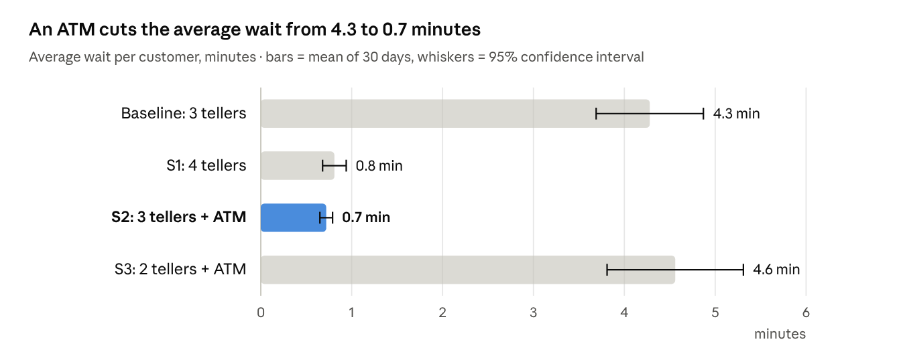
bank_sim.py (SimPy) · 30 replications per scenario, seeds 2026–2055
Measure | Baseline: 3 tellers | S1: 4 tellers | S2: 3 tellers + ATM | S3: 2 tellers + ATM
Customers waiting > 10 min (%) | 13.5 | 0.1 | 0.0 | 17.9
Longest wait (min) | 15.0 | 6.7 | 6.5 | 21.1
Average teller queue (people) | 2.8 | 0.5 | 0.3 | 2.8
Longest teller queue (people) | 10.4 | 6.0 | 4.4 | 9.9
Customers lost to balking (%) | 0.8 | 0.0 | 0.0 | 0.5
Teller utilization (%) | 88 | 68 | 60 | 87
ATM utilization (%) | — | — | 42 | 41
Overtime after closing (min) | 7.8 | 3.9 | 4.2 | 10.2
All values are means of 30 replications; about 234–239 customers are served per day in every scenario.

Why the results make sense
Queueing theory predicts this. Teller utilization is ρ = λ × E[S] / c:
\rho_{\text{baseline}} = \frac{(40/60) \times 4.17}{3} = 0.93 \qquad \rho_{\text{S2}} = \frac{(26/60) \times 4.17}{3} = 0.60
At ρ near 0.9 waits grow steeply, so moving 35% of customers to a 1.8-minute ATM drops the load to 0.6 and the queue almost disappears. The simulated baseline utilization (88%) sits a little below the theoretical 93% because the branch starts empty each morning and some customers balk. S2 and S3 teller loads (0.60 and 0.90) match the simulation's 60% and 87% closely, which validates the model.

Recommendation
Install one ATM. If the bank must cut costs instead, an ATM plus 2 tellers keeps service at today's level with one fewer teller.
To reproduce: pip install simpy matplotlib numpy then python bank_sim.py.

TA discussion
Lead with the recommendation and the chart, then show the AnyLogic animation running and explain how the Python model confirms its numbers.

Talking points
- System: a bank branch is a classic multi-server queue; we chose DES because customers are discrete entities competing for tellers.
- Why AnyLogic: drag-and-drop process blocks, animation, and built-in parameter variation; it could later add agent-based customer behaviour.
- Validation: an independent SimPy model and the utilization formula give the same results.
- Finding: an ATM removes 35% of the teller load, which beats adding a teller and can even replace one.

Likely questions
Question | Answer
Why exponential inter-arrival times? | Many independent customers arriving at random produce a Poisson process.
Why triangular service times? | They need only a minimum, most likely and maximum value, which are easy to estimate by observation.
Why 30 replications? | One run is a single random day; 30 runs give a mean with a 95% confidence interval.
Why no warm-up period? | The branch really opens empty each morning, so this is a terminating simulation.
How would you get real data? | Time arrivals and service at a branch for an hour and fit distributions.
What would you add next? | Lunch-time arrival peak, reneging (leaving after waiting), teller breaks, and cost per scenario.
What are the model's limits? | Parameters are assumed, not measured, and the arrival rate is constant all day.

Sources
- AnyLogic Help: editions and PLE limitations
- AnyLogic 9 release notes

